Kyushu Institute of Technology

Department of Applied Science for Integrated System Engineering





BIRDS-5 project

Vibration Test Report

Initial Release: 18/02/2020

Revision History

|  |  |  |  |
| --- | --- | --- | --- |
| **Date** | **Version Number** | **Writer** | **Annotation** |
| 2022/02/18 | NC | Victor Mukungunugwa | Initial Release |
| 2022/03/25 |  | Takashi Yamauchi | Natural frequency graph |

**Contents**

1. Purpose 3

2. Applicable Document 3

**3.** **Test method** 3

3.1. Test Objectives 3

3.2. Acceleration measurement point 3

3.5. Test Tolerance 7

3.6. Test Sequence 7

**4.** **Test Results** 8

4.1. Visual inspection 8

4.2. Random Vibration Test 15

4.2.1. X-axis vibration 15

4.2.2. Z-axis vibration 16

4.2.3. Y-axis vibration 17

4.3. Function Test 27

**5.** **Conclusion** 28

1. Purpose

This document summarizes the results of the Vibration Test for BIRDS-5 which will be deployed from JEM Small Satellites Orbital Deployer-R (J-SSOD-R).

1. Applicable Document
2. JX-ESPC-101132-D JEM Payload Accommodation Handbook-Vol.8-

Small Satellite Deployment Interface Control Document

1. JMX-2011303 Structure Verification and Fracture Control Plan for JAXA

Selected Small Satellite Released from J-SSOD

1. 15_BIRDS5-FCE-02(Φ3) Structure Fracture Control Evaluation Form for

Small Satellite deployed from J-SSOD

1. 16_BIRDS5-SAR-02(Φ3) BIRDS-5 Flight Safety Assessment Report

for phase III

# 

# **Test method**

The verification points are as follows,

1. No breakage in main structure
2. Main structure needs to satisfy specified natural frequency
3. Natural frequency before and after tests need to remain unchanged
4. No improper antenna deployment, and no malfunction to CubeSat
5. No breakage in glass material such as solar cell cover and camera lens
6. No loosening in all fasteners
   1. Test Objectives

**Table 3.1-1 Test Articles**

|  |  |  |  |
| --- | --- | --- | --- |
|  | **Article name** | **Number** | **Manufacturer** |
| **1** | PearlAfricaSat-1 | 1 | HMD |
| **2** | TAKA | 1 | HMD |
| **3** | ZimSat-1 | 1 | HMD |
| 4 | 2U Pod | 1 |  |

* 1. Acceleration measurement point

The vibration test was divided into 1Ux2 (PEARLAFRICASAT-1 and ZIMSAT-1) and 2Ux1 (TAKA). The acceleration measurement points are shown in Figures 3.2-1 to 3.2-6 and Table 3.2-1. “Ch.〇” are acceleration measurement points for data acquisition. “Control point 〇 (CP〇)” are acceleration measurement points for average value control for the vibration machine.





**Figure 3.2-1　Acceleration measurement point (X-axis) in PEARLAFRICASAT-1 and ZIMSAT-1 test.**



**Figure 3.2-2　Acceleration measurement point (Y-axis) in PEARLAFRICASAT-1 and ZIMSAT-1 test.**



**Figure 3.2-3　Acceleration measurement point (Z-axis) in PEARLAFRICASAT-1 and ZIMSAT-1 test.**

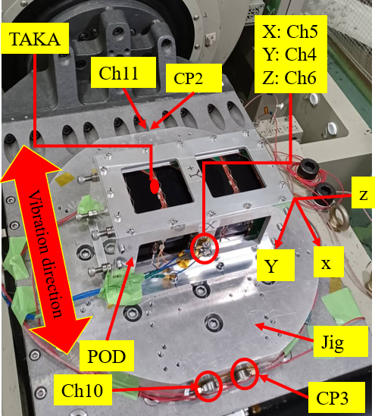

**Figure 3.2-4　Acceleration measurement point (X-axis) in TAKA test**

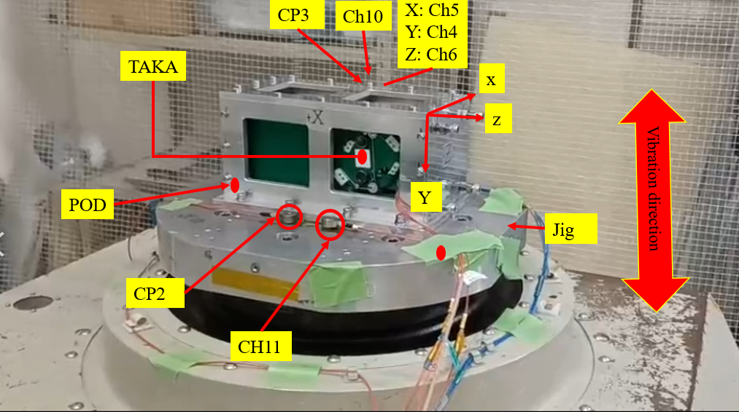

**Figure 3.2-5　Acceleration measurement point (Y-axis) in TAKA test**

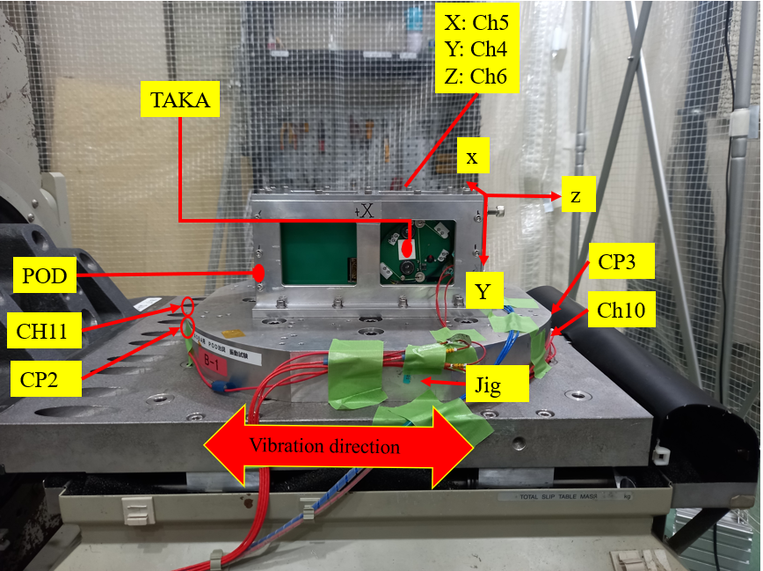

**Figure 3.2-6　Acceleration measurement point (Z-axis) in TAKA test**

**Table 3.2-1 Acceleration measurement point**

1. PEARLAFRICASAT-1 and ZIMSAT-1 test

|  |  |  |  |  |
| --- | --- | --- | --- | --- |
| Measurement point | Measurement axis | Acceleration sensor | CH | Note |
| Control Sensor | 1-axis | EM15 | CP2 |  |
| 1-axis | EM13 | CP3 |  |
| Jig | 1-axis | EM16 | Ch.10 |  |
| 1-axis | EM17 | Ch.11 |  |
| ZIMSAT-1 | X | tt04 | Ch.1 |  |
| Y | tt05 | Ch.2 |  |
| Z | tt06 | Ch.3 |  |
| PEARLAFRICASAT-1 | X | smart-pod-004 | Ch.4 |  |
| Y | smart-pod-007 | Ch.5 |  |
| Z | smart-pod-008 | Ch.6 |  |
| Pod | X | tt02 | Ch.7 |  |
| Y | tt01 | Ch.8 |  |
| Z | tt03 | Ch.9 |  |

1. TAKA test

|  |  |  |  |  |
| --- | --- | --- | --- | --- |
| Measurement point | Measurement axis | Acceleration sensor | CH | Note |
| Control Sensor | 1-axis | EM15 | CP2 |  |
| 1-axis | EM13 | CP3 |  |
| Jig | 1-axis | EM16 | Ch.10 |  |
| 1-axis | EM17 | Ch.11 |  |
| TAKA | X | smart-pod-004 | Ch.1 |  |
| Y | smart-pod-007 | Ch.2 |  |
| Z | smart-pod-008 | Ch.3 |  |
| Pod | X | tt02 | Ch.7 |  |
| Y | tt01 | Ch.8 |  |
| Z | tt03 | Ch.9 |  |

* 1. Test Contents

Following vibration tests were performed along X, Z and Y axes, respectively.

(1) Low level white noise vibration（Modal survey）

(2) Random vibration

* 1. Vibration Test Level

1. Low level white noise vibration (Modal Survey)

Modal survey test parameters are described in Table 3.4-1

**Table 3.4-1 Modal survey vibration environment**

|  |  |  |  |
| --- | --- | --- | --- |
|  | Frequency  [Hz] | Acceleration  [Grms] | Time  [sec] |
| Each axis | 20~2000 | 0.5 | 60 |

1. Random Vibration

The random vibration test level is shown in Table 3.4-2, the level is the envelope of the environments for HTV-X, Dragon and Cygnus (reference: JX-ESPC-101132-D). This test level was defined by Structure Fracture Control Evaluation Form.

**Table 3.4-2 Random vibration test level**

**(Envelope of the environments for HTV-X, Dragon and Cygnus)**

|  |  |
| --- | --- |
| **Freq. [Hz]** | **PSD [G2/Hz]** |
| 20 | 0.02 |
| 50 | 0.02 |
| 120 | 0.031 |
| 230 | 0.031 |
| 1000 | 0.0045 |
| 2000 | 0.0013 |
| Overall | 4.08 Grms |
| Duration | 60 sec/axis |
| Direction | 1. axes each |

## Test Tolerance

**<Random Vibration Test>**

1. Overall [Grms] : ±1.5dB
2. PSD [G2/Hz] : ＋3.0dB / －1.0dB
3. Frequency [Hz]: larger one of ±2% or 1 [Hz]
4. Duration [sec]: ＋10% / －0%

## Test Sequence

Table 3.6-1 shows the test sequence.

**Table 3.6-1 Test Sequence**

|  | Test Contents | Test ID |
| --- | --- | --- |
| Before vibration test | Visual inspection of satellite |  |
| Z-axis test | Satellite setup |  |
| Modal survey | 1-modal |
| Random vibration test | 2-random |
| Modal survey | 3-modal |
| X-axis test | Axis change |  |
| Modal survey | 4-modal |
| Random vibration test | 5-random |
| Modal survey | 6-modal |
| Y-axis test | Axis change |  |
| Modal survey | 7-modal |
| Random vibration test | 8-random |
| Modal survey | 9-modal |
| After vibration test | Visual inspection of satellite |  |
| Function test of satellite |  |

*: Order of direction was reversed for TAKA

# **Test Results**

Date：2022/02/14

Location：Center for Nanosatellite Testing (CeNT)

Laboratory of Lean Satellite Enterprises and In-Orbit Experiments

Kyushu Institute of Technology

* 1. Sensui, Tobata, Kitakyushu, 804-8550 Fukuoka, Japan

## Visual inspection

The visual inspection for the satellite was conducted before and after the test. No breakage was found in the satellites after the test. No deformation and damage were seen on the deployment switches. Also, no breakage in the solar cell cover glass, camera lens and filters were found. No loosening was found in all fasteners. There was also no inadvertent antenna deployment during and after the vibration. After the vibration test, the knot of the wire restraining the antenna was not loosened, and the wire was not damaged or stretched. No malfunction occurred to CubeSat, either. Test results show in Table 4.1-1 and Figure 4.1-1 to Figure 4.1-18.

**Table 4.1-1 Inspection Result**

|  |  |  |  |
| --- | --- | --- | --- |
|  | Part Name | Quantity | Inspection Result |
| 1 | PEARLAFRICASAT-1 |  |  |
| 1-1 | External panel | 6 | Pass |
| 1-2 | Solar panel cover glass | 10 | Pass |
| 1-3 | Camera lens | 3 | Pass |
| 1-4 | Camera filters | 2 | Pass |
| 1-5 | Torque mark | 53 | Pass |
| 1-6 | Antenna mechanism | 4 | Pass |
| 2 | ZIMSAT-1 |  |  |
| 2-1 | External panel | 6 | Pass |
| 2-2 | Solar panel cover glass | 10 | Pass |
| 2-3 | Camera lens | 3 | Pass |
| 2-4 | Camera filters | 2 | Pass |
| 2-5 | Torque mark | 53 | Pass |
| 2-6 | Antenna mechanism | 4 | Pass |
| 3 | TAKA |  |  |
| 3-1 | External panel | 5 | Pass |
| 3-2 | Solar panel cover glass | 14 | Pass |
| 3-3 | Camera lens | 3 | Pass |
| 3-4 | Camera filters | 2 | Pass |
| 3-5 | Torque mark | 72 | Pass |
| 3-6 | Antenna mechanism | 4 | Pass |

1. PEARLAFRICASAT-1

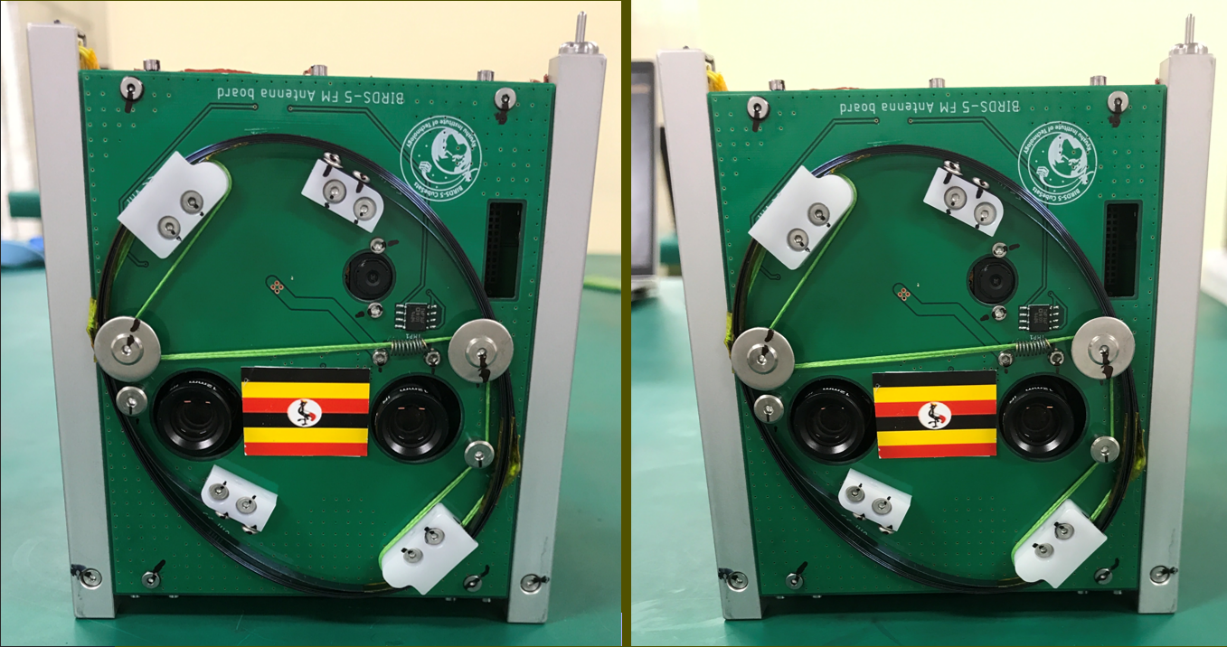

**Figure 4.1-1 Photo on the +X surface (Left: before test Right: after test)**

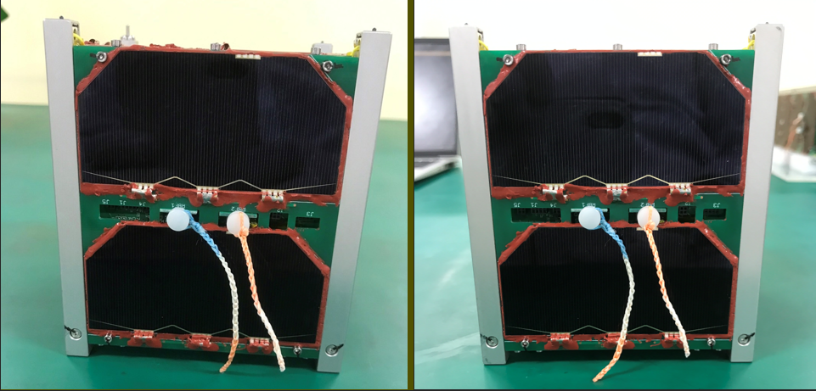

**Figure 4.1-2 Photo on the -X surface (Left: before test Right: after test)**

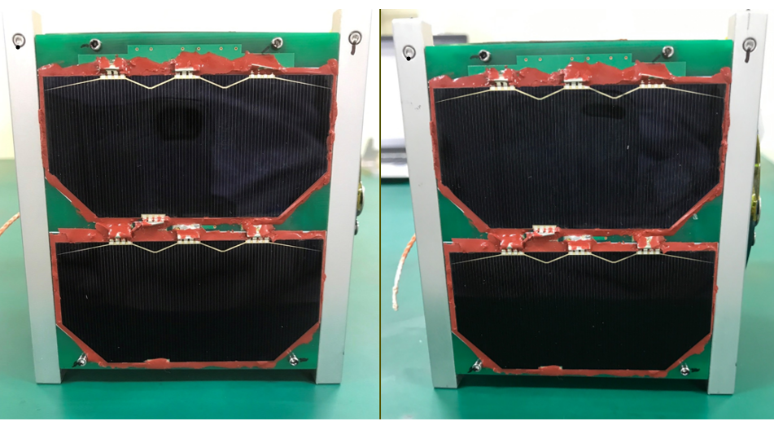

**Figure 4.1-3 Photo on the +Y surface (Left: before test Right: after test)**

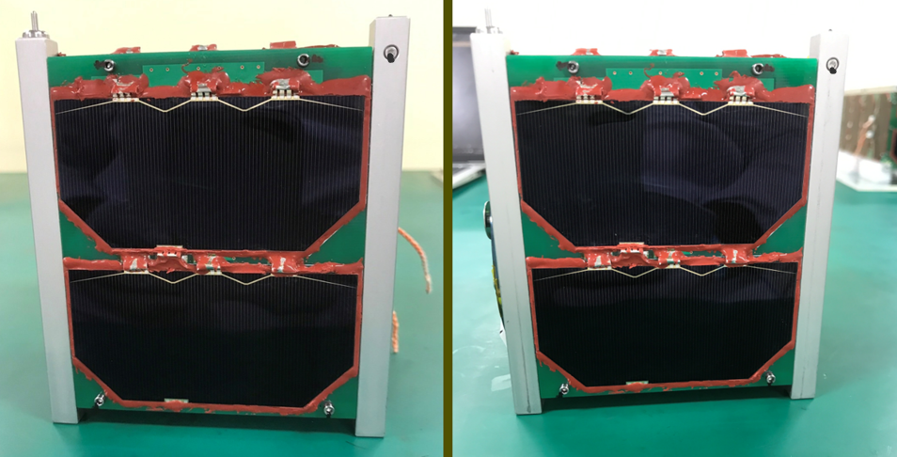

**Figure 4.1-4 Photo on the -Y surface (Left: before test Right: after test)**

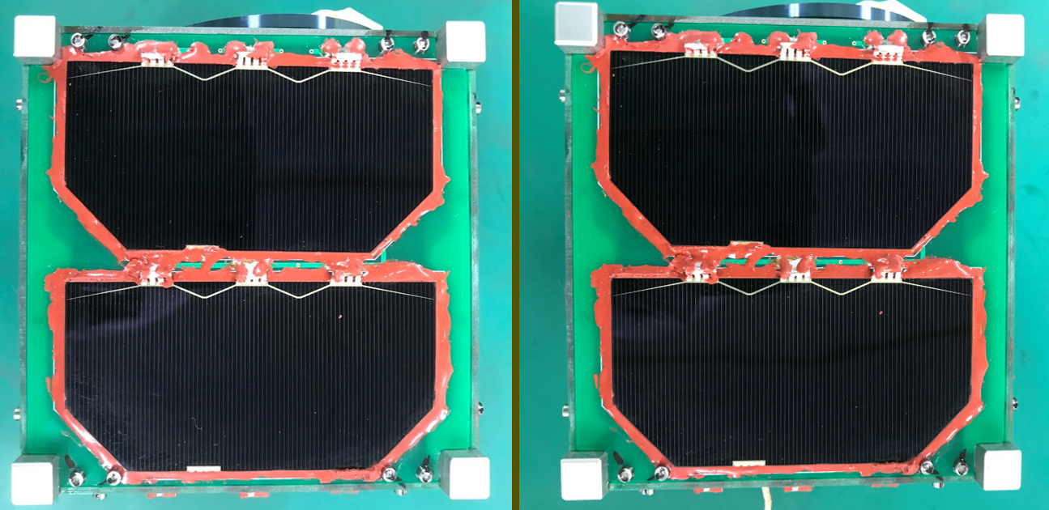

**Figure 4.1-5 Photo on the +Z surface (Left: before test Right: after test)**

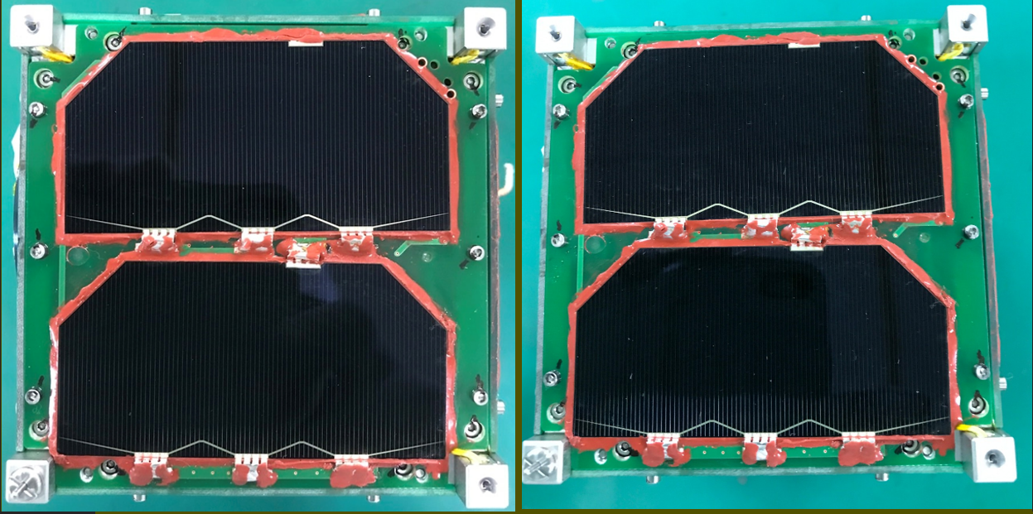

**Figure 4.1-6 Photo on the -Z surface (Left: before test Right: after test)**

1. ZIMSAT-1

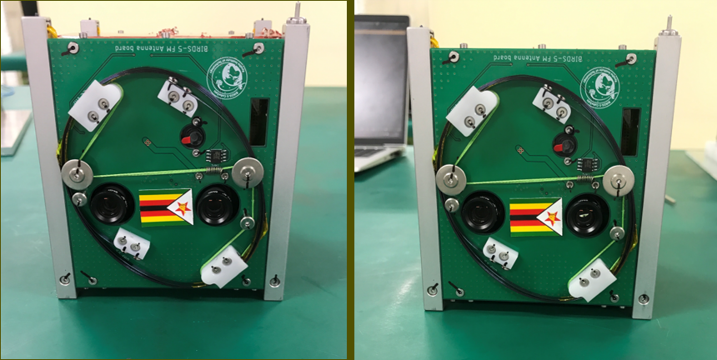

**Figure 4.1-7 Photo on the +X surface (Left: before test Right: after test)**

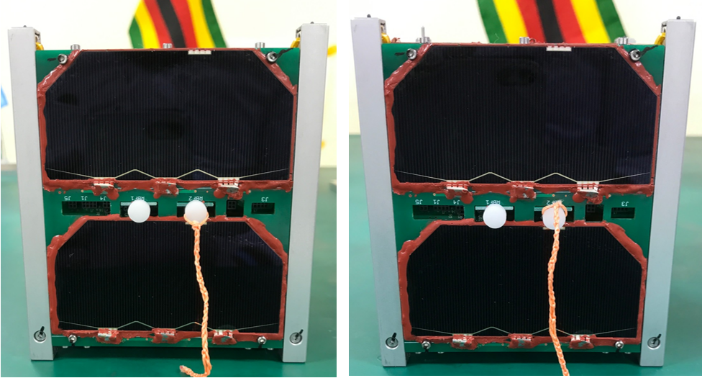

**Figure 4.1-8 Photo on the -X surface (Left: before test Right: after test)**

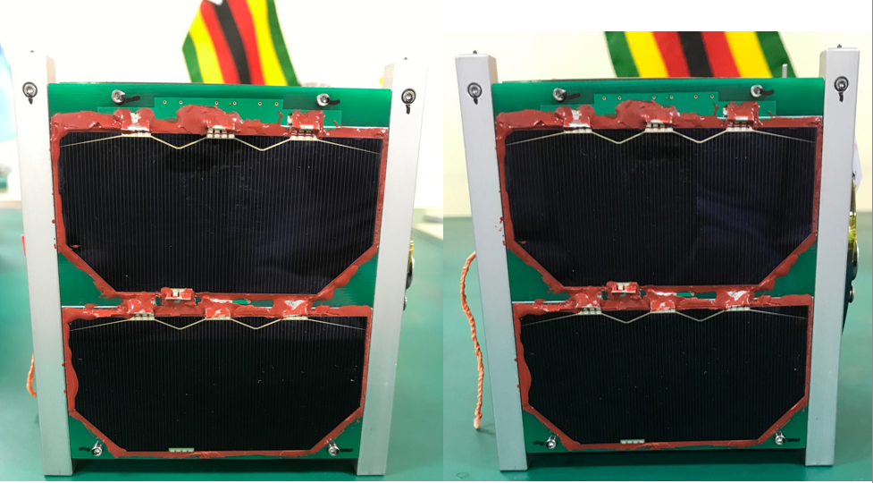

**Figure 4.1-9 Photo on the +Y surface (Left: before test Right: after test)**

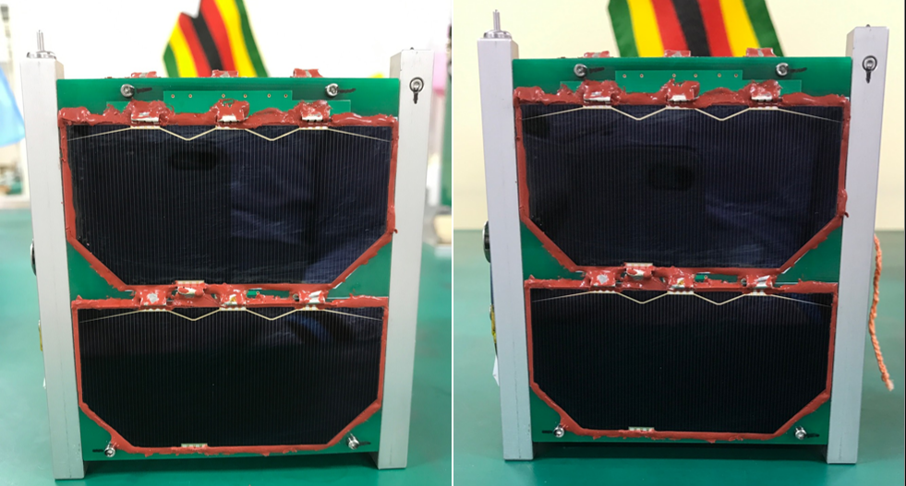

**Figure 4.1-10 Photo on the -Y surface (Left: before test Right: after test)**

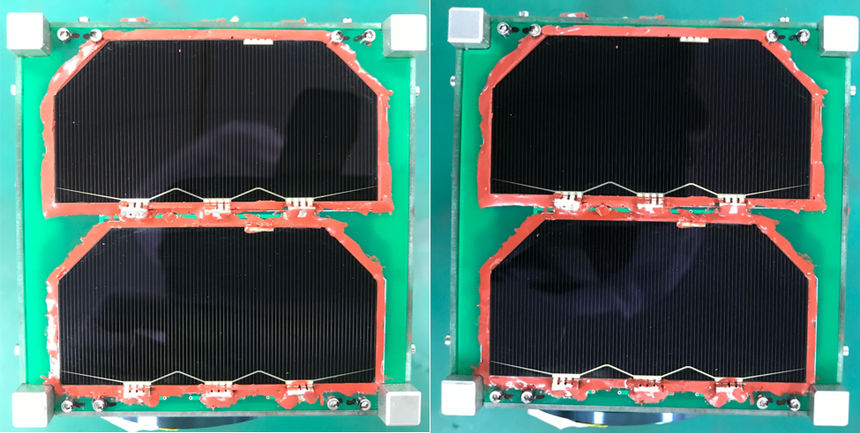

**Figure 4.1-11 Photo on the +Z surface (Left: before test Right: after test)**

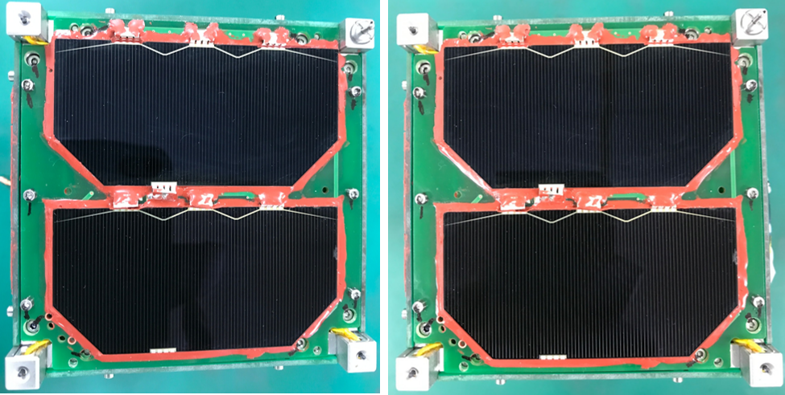

**Figure 4.1-12 Photo on the -Z surface (Left: before test Right: after test)**

1. TAKA

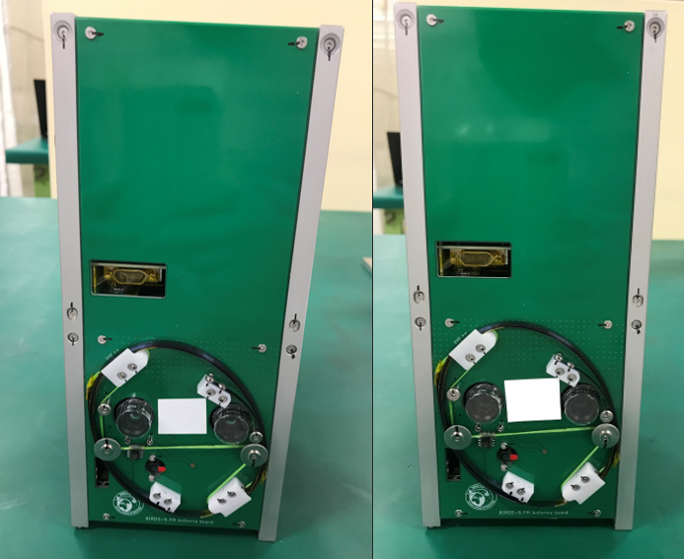  
**Figure 4.1-13 Photo on the +X surface (Left: before test Right: after test)**

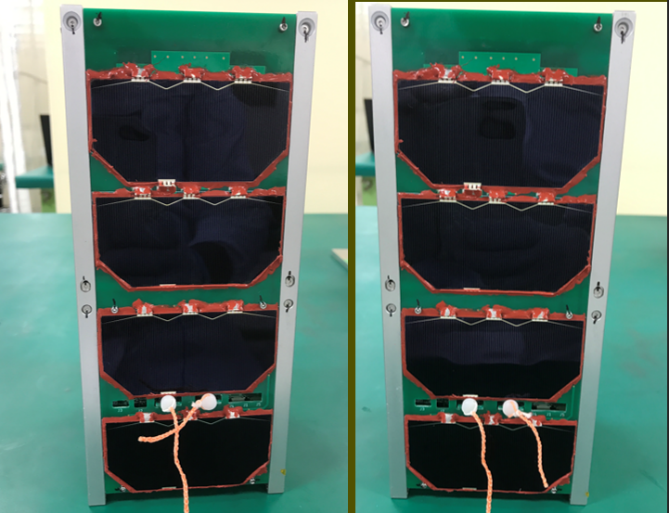

**Figure 4.1-14 Photo on the -X surface (Left: before test Right: after test)**

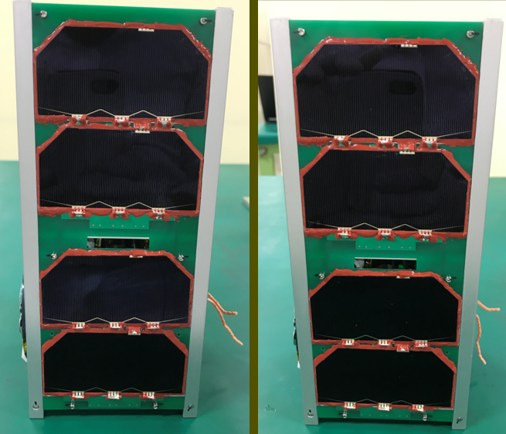

**Figure 4.1-15 Photo on the +Y surface (Left: before test Right: after test)**

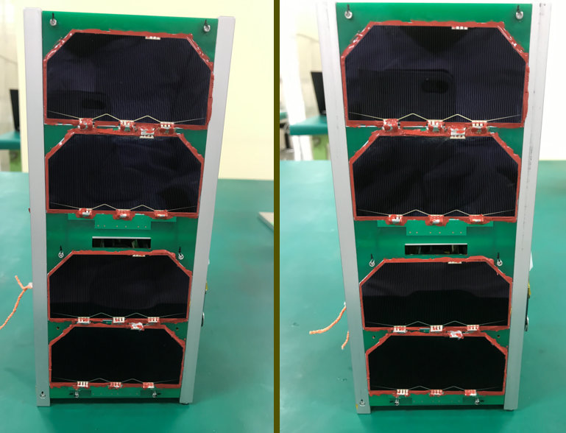

**Figure 4.1-16 Photo on the -Y surface (Left: before test Right: after test)**

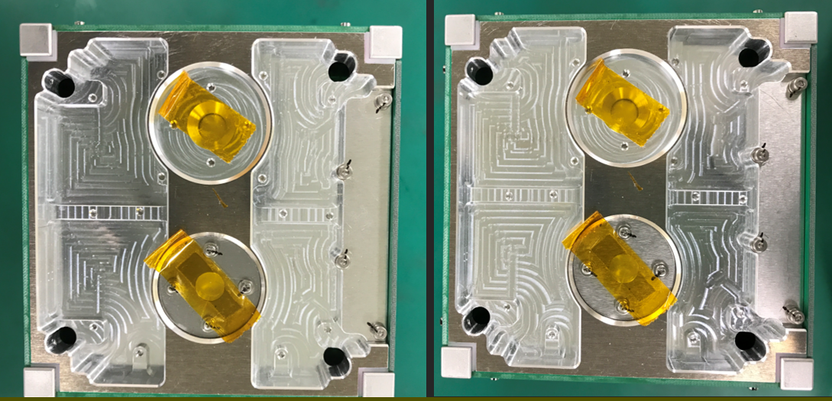

**Figure 4.1-17 Photo on the +Z surface (Left: before test Right: after test)**

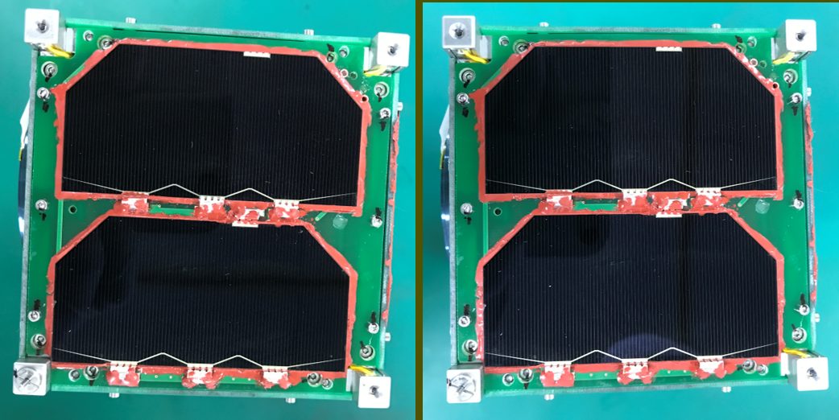

**Figure 4.1-18 Photo on the -Z surface (Left: before test Right: after test)**

## Random Vibration Test

* + 1. **PEARLAFRICASAT-1**

### X-axis vibration

The required acceptance level of vibration was met by the vibration machine. Test results show in Figure 4.2.1.1-1 to Figure 4.2.1.1-2.

In the modal survey before and after the random vibration, the resonant frequency was 347 Hz and 339 Hz, respectively. There is no significant change in the minimum natural frequency before and after the random vibration. It is 60Hz or higher and meets the requirements.

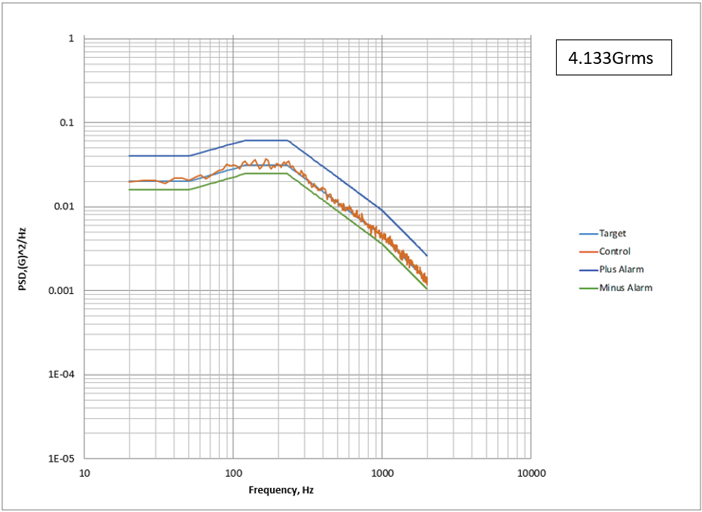

**Figure 4.2.1.1-1　X-axis random vibration at Control Sensor**





**Figure 4.2.1.1-2 Modal Survey before Vibrating X-axis at Mesurement Point (Ch.4)**

**(Left: before, Right: after)**

### Z-axis vibration

The required acceptance level of vibration was met by the vibration machine. Test results show in Figure 4.2.1.2-1 to Figure 4.2.1.2-2.

In the modal survey before and after the random vibration, the resonant frequency was 317 Hz and 324 Hz, respectively. There is no significant change in the minimum natural frequency before and after the random vibration. It is 60Hz or higher and meets the requirements.

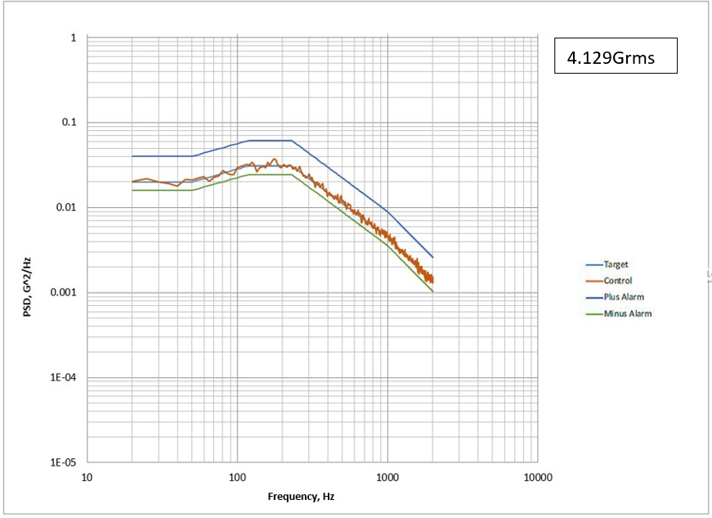

**Figure 4.2.1.2-1　Z-axis random vibration at Control Sensor**





**Figure 4.2.1.2-2 Modal Survey before Vibrating Z-axis at Mesurement Point (Ch.6)**

**(Left: before, Right: after)**

### Y-axis vibration

The required acceptance level of vibration was met by the vibration machine. Test results show in Figure 4.2.1.3-1 to Figure 4.2.1.3-2.

In the modal survey before and after the random vibration, the resonant frequency was 321 Hz and 323 Hz, respectively. There is no significant change in the minimum natural frequency before and after the random vibration. It is 60Hz or higher and meets the requirements.

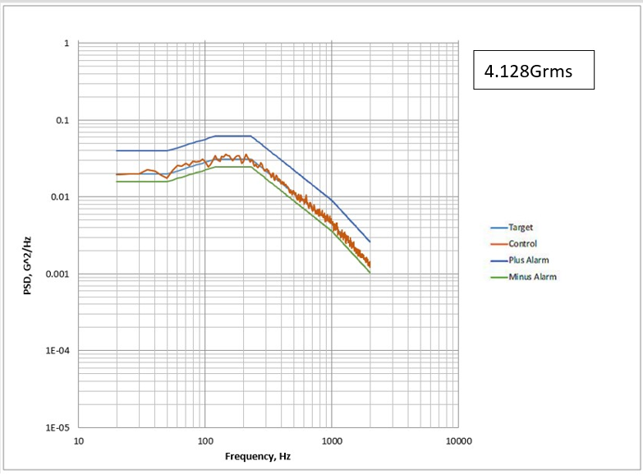

**Figure 4.2.1.3-1　Y-axis random vibration at Control Sensor**





**Figure 4.2.1.3-2 Modal Survey before Vibrating Y-axis at Mesurement Point (Ch.5)**

**(Left: before, Right: after)**

* + 1. **ZIMSAT-1**

### X-axis vibration

The required acceptance level of vibration was met by the vibration machine. Test results show in Figure 4.2.2.1-1 to Figure 4.2.2.1-2.

In the modal survey before and after the random vibration, the resonant frequency was 308 Hz and 306 Hz, respectively. There is no significant change in the minimum natural frequency before and after the random vibration. It is 60Hz or higher and meets the requirements.



**Figure 4.2.2.1-1　X-axis random vibration at Control Sensor**





**Figure 4.2.2.1-2 Modal Survey before Vibrating X-axis at Mesurement Point (Ch.1)**

**(Left: before, Right: after)**

### Z-axis vibration

The required acceptance level of vibration was met by the vibration machine. Test results show in Figure 4.2.2.2-1 to Figure 4.2.2.2-2.

In the modal survey before and after the random vibration, the resonant frequency was 317 Hz and 324 Hz, respectively. There is no significant change in the minimum natural frequency before and after the random vibration. It is 60Hz or higher and meets the requirements.



**Figure 4.2.2.2-1　Z-axis random vibration at Control Sensor**





**Figure 4.2.2.2-2 Modal Survey before Vibrating Z-axis at Mesurement Point (Ch.3)**

**(Left: before, Right: after)**

### Y-axis vibration

The required acceptance level of vibration was met by the vibration machine. Test results show in Figure 4.2.2.3-1 to Figure 4.2.2.3-2.

In the modal survey before and after the random vibration, the resonant frequency was 346 Hz and 335Hz, respectively. There is no significant change in the minimum natural frequency before and after the random vibration. It is 60Hz or higher and meets the requirements.



**Figure 4.2.2.3-1　Y-axis random vibration at Control Sensor**





**Figure 4.2.2.3-2 Modal Survey before Vibrating Y-axis at Mesurement Point (Ch.2)**

**(Left: before, Right: after)**

* + 1. **TAKA**

### X-axis vibration

The required acceptance level of vibration was met by the vibration machine. Test results show in Figure 4.2.3.1-1 to Figure 4.2.3.1-2.

In the modal survey before and after the random vibration, the resonant frequency was 290 Hz and 279 Hz, respectively. There is no significant change in the minimum natural frequency before and after the random vibration. It is 60Hz or higher and meets the requirements.

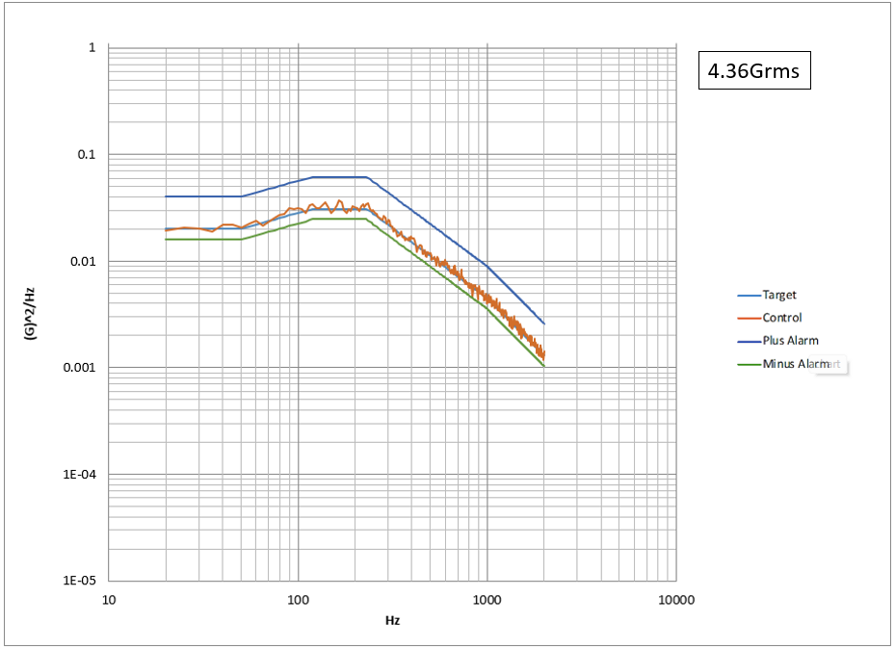

**Figure 4.2.3.1-1　X-axis random vibration at Control Sensor**





**Figure 4.2.3.1-2 Modal Survey before Vibrating X-axis at Mesurement Point (Ch.1)**

**(Left: before, Right: after)**

### Z-axis vibration

The required acceptance level of vibration was met by the vibration machine. Test results show in Figure 4.2.3.2-1 to Figure 4.2.3.2-2.

In the modal survey before and after the random vibration, the resonant frequency was 321 Hz and 305 Hz, respectively. There is no significant change in the minimum natural frequency before and after the random vibration. It is 60Hz or higher and meets the requirements.

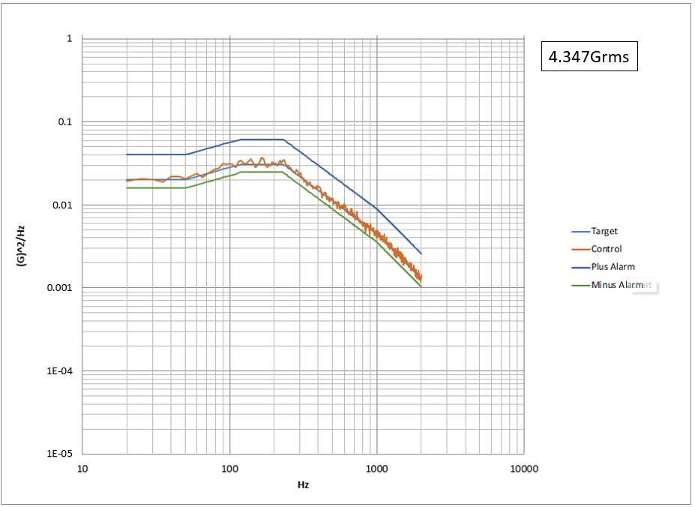

**Figure 4.2.3.2-1　Z-axis random vibration at Control Sensor**





**Figure 4.2.3.2-2 Modal Survey before Vibrating Z-axis at Mesurement Point (Ch.3)**

**(Left: before, Right: after)**

### Y-axis vibration

The required acceptance level of vibration was met by the vibration machine. Test results show in Figure 4.2.3.3-1 to Figure 4.2.3.3-2.

In the modal survey before and after the random vibration, the resonant frequency was 326 Hz and 317 Hz, respectively. There is no significant change in the minimum natural frequency before and after the random vibration. It is 60Hz or higher and meets the requirements.

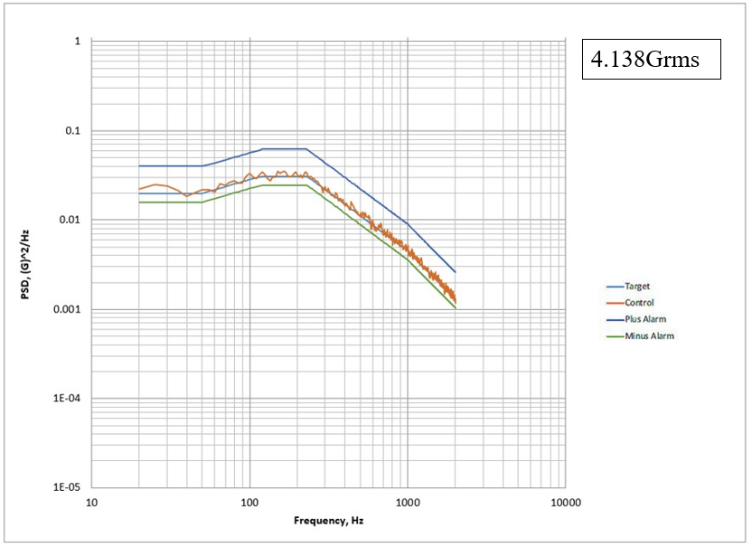

**Figure 4.2.3.3-1　Y-axis random vibration at Control Sensor**





**Figure 4.2.3.3-2 Modal Survey before Vibrating Y-axis at Measurement Point (Ch.2)**

**(Left: before, Right: after)**

## Function Test

There was no failure or abnormal status on the voltage of battery and health data of the OBC (On-Board Computer) after vibration test. The satellite had no damage from vibration environment.

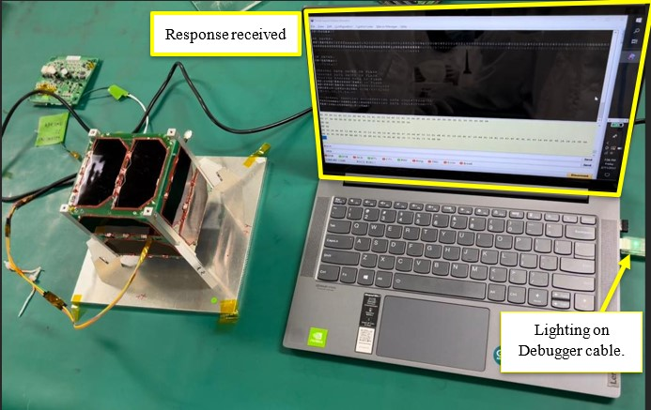

**Figure 4.3-1 PEARLAFRICASAT-1: When DepSW1 was released, SepSW3 got closed, and battery supplied power to the load.**

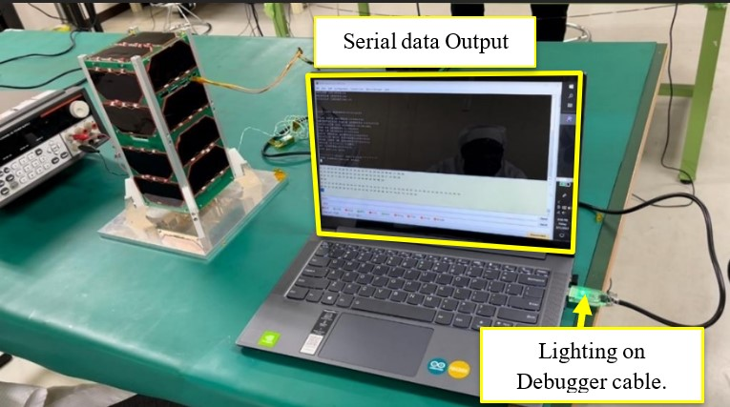

**Figure 4.3-1 TAKA : When DepSW1 was released, SepSW3 got closed, and battery supplied power to the load.**

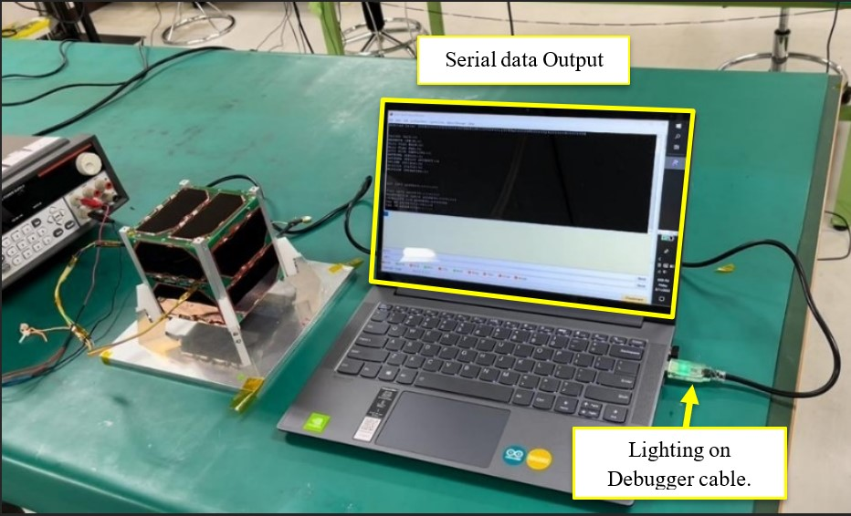

**Figure 4.3-3 ZIMSAT-1: When DepSW1 was released, SepSW3 got closed, and battery supplied power to the load.**

# **Conclusion**

No distortion or damage were found on the BIRDS-5 flight models. No loosening was found in the fasteners which constitute a main structure. Moreover, no breakage of the external panel, the solar cell cover glass, camera lens and filters were found based on visual inspection after the vibration.

The minimum natural frequency of each axis is 60Hz or higher, which meets the requirements. The minimum natural frequency of the measured satellite did not change significantly before and after the random vibration test.

There was no inadvertent antenna deployment during and after the vibration. The knot of the wire restraining the antenna was not loosened, and the wire was not damaged or stretched.

No malfunction occurred to CubeSat, either.

In conclusion, the results of the vibration test show that the PEARLAFRICASAT-1, TAKA and ZIMSAT-1 flight models have successfully passed all requirements and is ready to launch.

|  |  |  |
| --- | --- | --- |
| **No** | **Verification Items** | **Results** |
| **1** | PEARLAFRICASAT-1 |  |
| **1-1** | No breakage in main structure | **Pass** |
| **1-2** | Main structure needs to satisfy specified natural frequency | **Pass** |
| **1-3** | Natural frequency before and after tests need to remain unchanged | **Pass** |
| **1-4** | No improper antenna deployment, and no malfunction to CubeSat | **Pass** |
| **1-5** | No breakage in glass material such as solar cell cover, camera lens and filters | **Pass** |
| **1-6** | No loosening in all fasteners as stated in the structural analysis report and is listed below:  #1-1 to #1-8, #2-1 to #2-6,#3-1 to #3-19,#4-1-#4-4,#5-1-#5-4, ,#6-1-#6-4,#7-9-#7-16,#7-33-#7-39  The screws are represented in fig 4.3.3-1 to 7 and fig 4.3.3-9 to 10 | **Pass** |
| **2** | ZIMSAT-1 |  |
| **2-1** | No breakage in main structure | **Pass** |
| **2-2** | Main structure needs to satisfy specified natural frequency | **Pass** |
| **2-3** | Natural frequency before and after tests need to remain unchanged | **Pass** |
| **2-4** | No improper antenna deployment, and no malfunction to CubeSat | **Pass** |
| **2-5** | No breakage in glass material such as solar cell cover, camera lens and filters | **Pass** |
| **2-6** | No loosening in all fasteners as stated in the structural analysis report and is listed below:  #1-1 to #1-4, #2-1 to #2-6,#3-1 to #3-18,#4-1-#4-6,#5-1-#5-6, ,#6-1-#6-6,#7-7-#7-10 ,#7-13-#7-16,#7-33-#7-47,  The screws are represented in fig 5.3.3-1 to 7 and fig 5.3.3-9 to 10 | **Pass** |
| **3** | TAKA |  |
| **3-1** | No breakage in main structure | **Pass** |
| **3-2** | Main structure needs to satisfy specified natural frequency | **Pass** |
| **3-3** | Natural frequency before and after tests need to remain unchanged | **Pass** |
| **3-4** | No improper antenna deployment, and no malfunction to CubeSat | **Pass** |
| **3-5** | No breakage in glass material such as solar cell cover, camera lens and filters | **Pass** |
| **3-6** | No loosening in all fasteners as stated in the structural analysis report and is listed below:  #1-1 to #1-8, #2-1 to #2-6,#3-1 to #3-19,#4-1-#4-4,#5-1-#5-4, ,#6-1-#6-4,#7-9-#7-16,#7-33-#7-39  The screws are represented in fig 4.3.3-1 to 7 and fig 4.3.3-9 to 10 | **Pass** |

|  |  |  |  |  |
| --- | --- | --- | --- | --- |
|  |  | **Natural Frequency (Hz)** | |  |
| **Satellite** |  | **a. Pre-Modal** | **b. Analysis** | **a/b** |
| PEARLAFRICASAT-1 | X | 340 | 435 | 78% |
| Y | 345 | 513 | 67% |
| Z | 317 | 587 | 54% |
| ZIMSAT-1 | X | 308 | 435 | 71% |
| Y | 341 | 513 | 67% |
| Z | 326 | 587 | 55% |
| TAKA | X | 330 | 244.9 | 135% |
| Y | 326 | 381.7 | 85% |
| Z | 471 | 529.2 | 89% |